Dungca, Cedric Luis R. July 4, 2025

WD-301 | 6WCSERVER

Laboratory Activity 2: Greeting Program

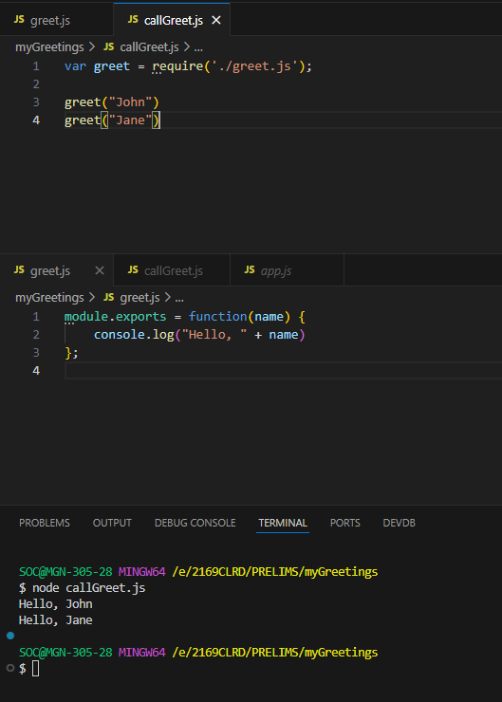

**Reflection:**

I learned and recapped what I have been taught on the second week of class. It was confusing at first as there were many error with the require path, but it was easy when I needed to export it and create a function and call it.